1. Docker:
   1. It is a container Technology.
   2. It is a tool for creating and managing containers.
2. What is a Container in software development and why to use it:  
   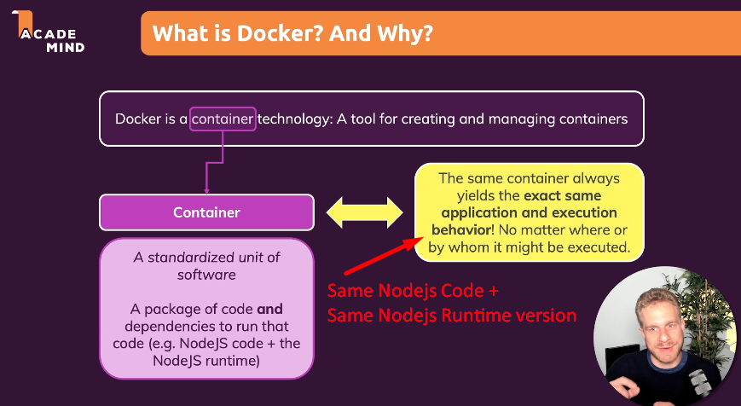
   1. In software development, a container is standardized unit of software.
   2. If we have a Nodejs app, then it has the followings:
      1. Container = Nodejs Code + Its dependencies + other binaries to run first two.
   3. Same container (Same Nodejs code + Same Nodejs Runtime Version) gives you the same result.  
      This is because everything is backed into the container.
3. 
4. 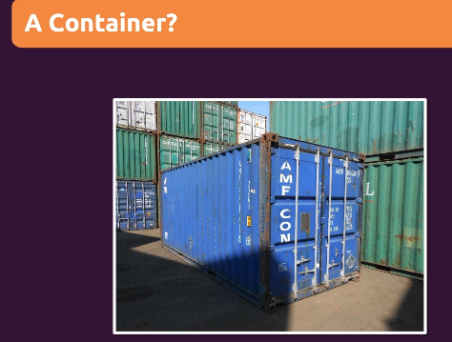
   1. Now take analogy.
   2. You take a container and make is suitable as per your goods.
   3. You need cooling, so you arrange cooling system into the container and put your goods inside it.
   4. Now this container is self-contained and isolated.   
      Goods don’t get mix with other containers.
   5. Now you can load this container onto any ship.
   6. So, this way container works stand-alone.
5. That is exactly the same with Docker Container.
6. We have our code, dependencies and the binaries for the environment inside the container and we can move this container anywhere wherever Docker is.
7. Then we will be able to run exactly the same application with the same environment wherever we go.
8. We don’t need to install any tools to run our app.
9. 